Zebra Printer ZD420 Reset

Printer Reset: (make sure the printers are powered on)

**Option 1:**

1. Turn off printer
2. Hold down the (II) power and (o->) feed buttons.
3. While holding the power/feed buttons, press the  POWER button/
4. Hold the three buttons until the ***status*** is the only button illuminated in orange.

**Option 2:**

1. Turn the printer over to expose the bottom.
   1. Use a small paperclip to push the reset button under the small hole in the middle of the printer.
   2. Hold the reset button down for 8 seconds with the paperclip.
   3. The printer will then print out the configuration. The network icon on the front panel will remain red. The printer is now reset.

**Printer Configuration:**

1. Connect the Zebra printer to a Windows 10 machine via a USB cable.
2. Open the *Zebra Setup Utilities*, and select the Zebra printer you’re working with.

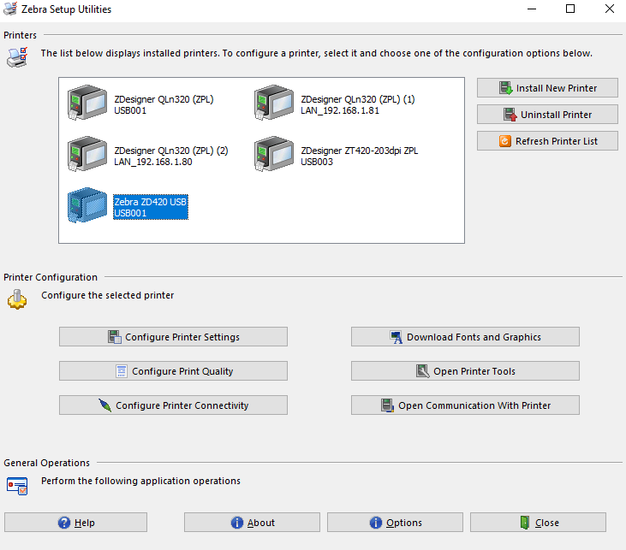

1. In the *Setup Utilities* Menu, click *“Configure Printer Settings.”* 
2. Enter the following into the Width/Height:
   1. Width: 3.00”
   2. Height: 2.00”
   3. Orientation: Normal

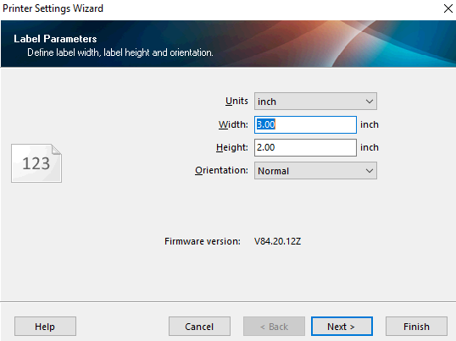.

* 1. Click ***NEXT.***

1. Enter the following:
   1. Draft Mode: Off
   2. Speed: 6.0
   3. Darkness: 15

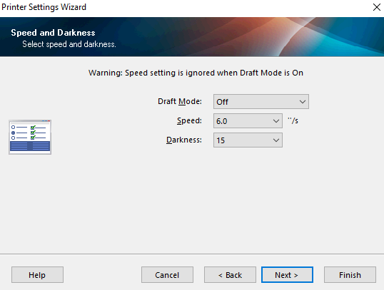

* 1. Click ***NEXT.***

1. On the *Media setting*, change the following:
   1. Print Mode: Direct
   2. Media Type: Web sensing
   3. Tear Off Adjust and Label Shift: 0.00

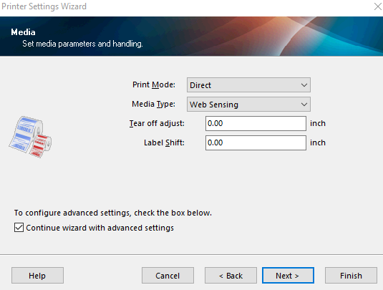

1. On the *Advance Setting*, change the following:
   1. Media Handling: Cutter

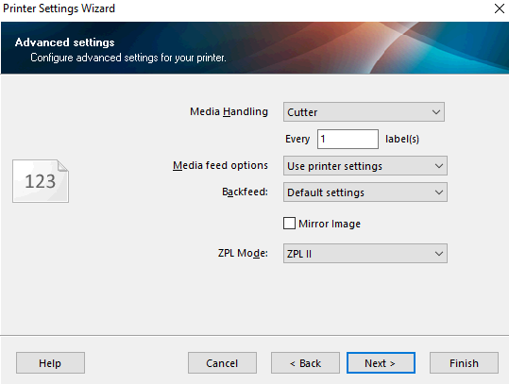

* 1. Click **FINISH.**

(Next Page)

Printer Configuration:

1. In the *Setup Utilities* Menu, click *“Configure Printer Connectivity.”*



1. On the *Connectivity Type menu,* click on *WIRELESS*.

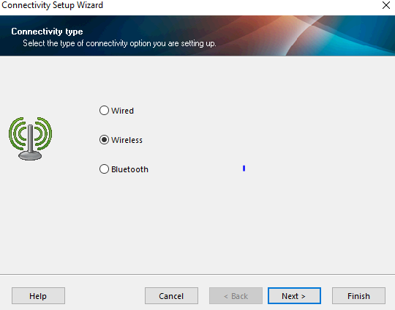

Click ***NEXT.***

1. *Click NEXT*, for the *Print Server Type*
2. *On the IP Address setting: (Leave HOSTNAME blank!)*
   1. Click on the *STATIC* button
   2. Enter the following info for static IP settings:
      1. IP Address: 192.168.8.XXX (Windmill)  
         IP Address: 192.168.100.XXX (Midtown)

IP Address: 192.168.120.XXX (Highland)

* + 1. Subnet Mask: 255.255.240.0 (Windmill)  
       Subnet Mask: 255.255.255.0 (Midtown)

Subnet Mask: 255.255.255.0 (Highland)

* + 1. Default Gateway: 192.168.0.5 (Windmill)  
       Default Gateway: 192.168.100.1 (Midtown) Default Gateway: 192.168.120.1 (Highland)

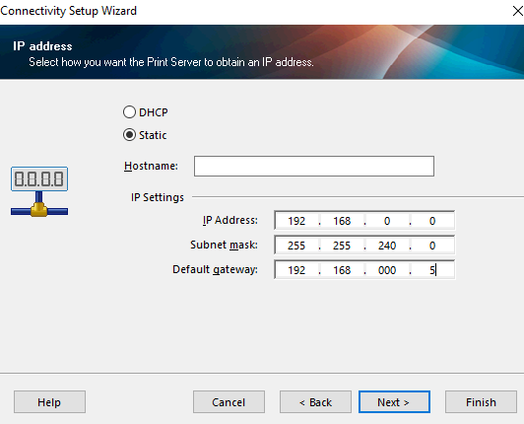

Click ***NEXT.***

1. On the Wireless Radio Settings:
   1. Band: 802.11 a/b/g/n (2.4 Ghz/ 5Ghz)

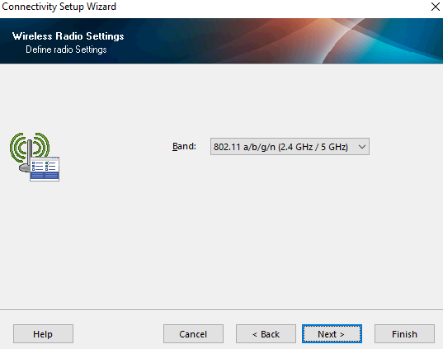

Click ***Next.***

1. On the Wireless Radio Settings:
   1. WLAN Country: USA, Canada

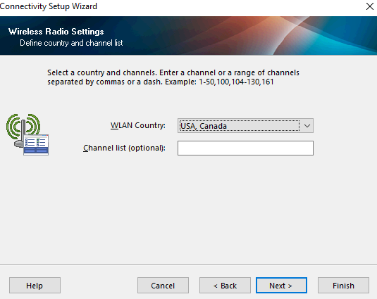

Click ***NEXT.***

1. On the Wireless Settings:
   1. Enter the following:
      1. **ESSID: GoVGK**

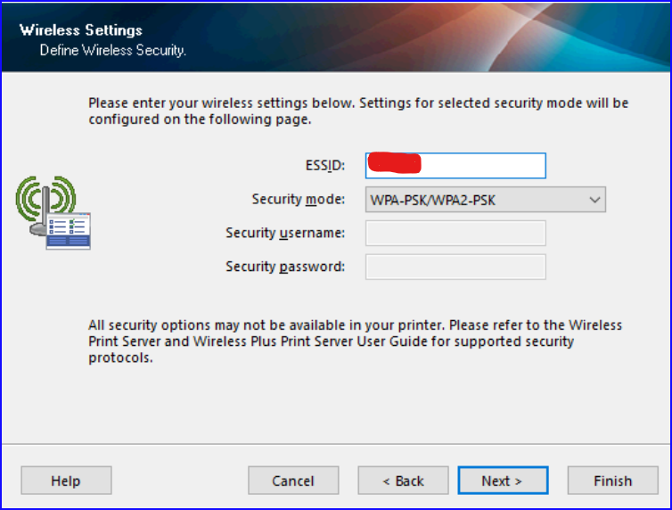

* 1. Select “***String****”*, and **enter the password** for the network.

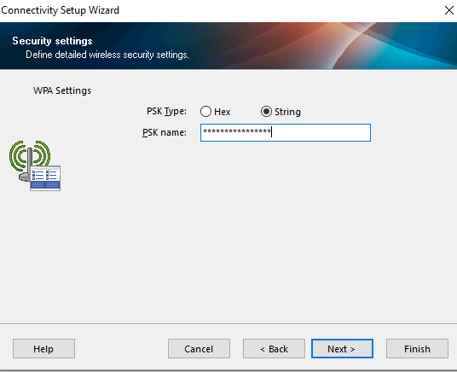

Click ***FINISH.***

*** The printer will reboot and will go through diagnostic. If successful, the network connectivity icon will show GREEN within 15 seconds.